EXERCISE 4:
Using your own database, please run the lab5.sql file and write an SQL statement along with output to answer each of the following queries (it might be helpful if you draw the relational model for the given SQL script first):

- List the names and addresses of all guests who are from London, alphabetically ordered by guest name.
select g.guestname, g.guestaddress
from guest g
where g.guestaddress like '%London'
order by g.guestname

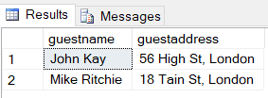

- Display the names of all the guests who have not provided any end date for their reservations.
select g.guestname
from guest g inner join booking b on g.guestno = b.guestno
where b.dateto is null

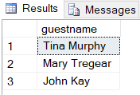

- Display the name and city of the hotels where guest’s from London are staying. The list should not contain any hotel more than once.
select distinct h.hotelname, h.city
from hotel h inner join room r on h.hotelno = r.hotelno
inner join booking b on r.hotelno = b.hotelno
inner join guest g on b.guestno = g.guestno
where g.guestaddress like '%London'

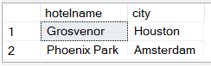
- Display the average room price of the hotels situated in London.
select avg(r.price) avgPrice
from room r inner join hotel h on r.hotelno = h.hotelno
where h.city = 'London'

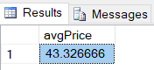

- Display the most expensive double, single and family room respectively (across hotels).
select r.type, max(r.price) maxPrice
from room r
where r.type = 'double'
group by r.type

select r.type, max(r.price) maxPrice
from room r
where r.type = 'single'
group by r.type

select r.type, max(r.price) maxPrice
from room r
where r.type = 'family'
group by r.type

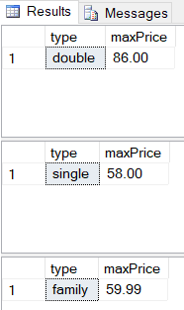

- Display the names of all the hotels along with the number of rooms present in each of them.
select h.hotelname, count(*) noOfRooms
from hotel h inner join room r on h.hotelno = r.hotelno
group by hotelname

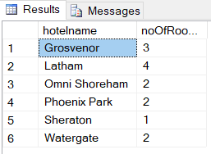

- Display hotel name and city name along with distinct number of room types available in each of them.
select h.hotelname, h.city, count(*) familyCount
from hotel h inner join room r on h.hotelno = r.hotelno
where r.type = 'family'
group by h.hotelname, h.city

select h.hotelname, h.city, count(*) singleCount
from hotel h inner join room r on h.hotelno = r.hotelno
where r.type = 'single'
group by h.hotelname, h.city

select h.hotelname, h.city, count(*) doubleCount
from hotel h inner join room r on h.hotelno = r.hotelno
where r.type = 'double'
group by h.hotelname, h.city

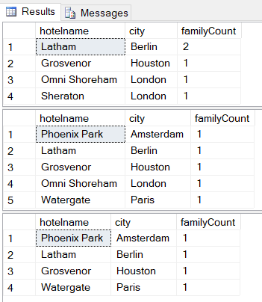

- Display a sorted list of hotel names along with the date for which a room was booked in the hotel. Please note null should be displayed booking date if the hotel has never been reserved by anyone.
select h.hotelname, b.datefrom
from hotel h inner join room r on h.hotelno = r.hotelno
left outer join booking b on r.hotelno = b.hotelno
order by h.hotelname

